Third Moment: Skewness
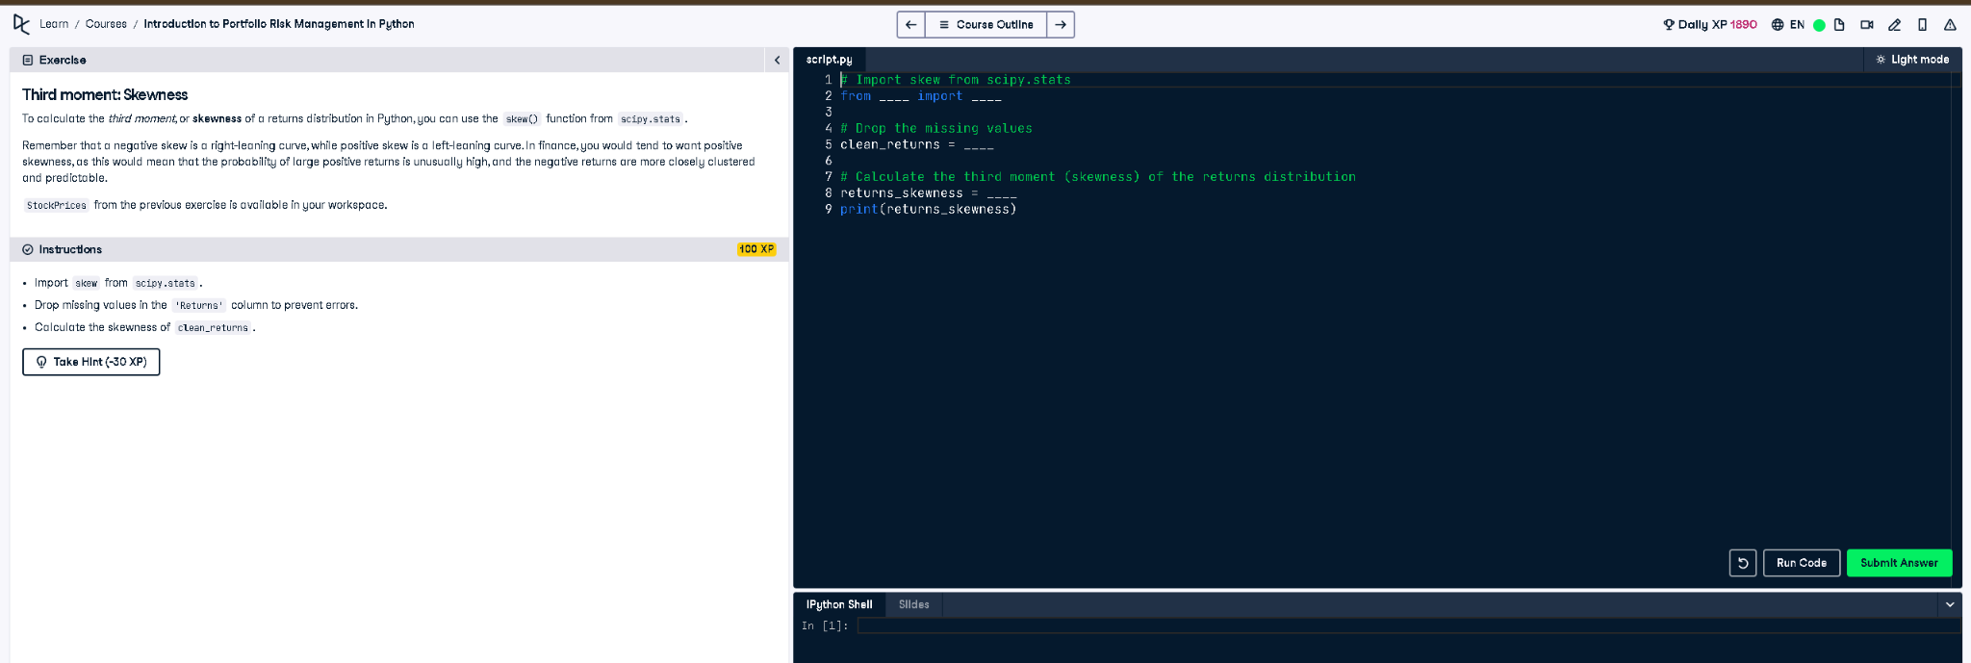

Python Code
# Import skew from scipy.stats
from scipy.stats import skew
# Drop the missing values
clean_returns = StockPrices['Returns'].dropna()
# Calculate the third moment (skewness) of the returns distribution
returns_skewness = skew(clean_returns)
print(returns_skewness)

Explanation (Simple Words)
To measure skewness (third moment), we first remove missing values from the returns. Then, we use `skew()` from `scipy.stats` to compute how returns are asymmetrically distributed. Positive skew means more small losses and rare big gains; negative skew is the opposite, indicating common small gains and rare big losses.

